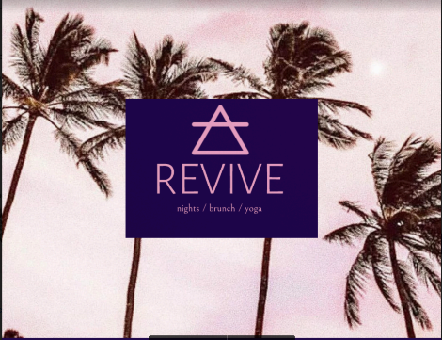

Revive Events Group

87 South Parade

Northallerton

DL7 8SJ

Dated: 31/05/2019

[***Team@reviveeventsgroup.co.uk***](mailto:Team@reviveeventsgroup.co.uk)

**Receipt Number: 0017**

**Receipt Date: 31 May 2019**

**Description:**

Paid by **Pure Skin**

Paid for Promotion services with Revive events group

**Sum: Received £50**

**Bank Transfer details**

Please credit the amount of £50

S A Williams

Barclays Bank

Sort :20-37-13

Account 63399958

Thank you for your sponsorship and support.

Simon Williams

Director

[**Simon@reviveeventsgroup.co.uk**](mailto:Simon@reviveeventsgroup.co.uk)

[@reviveeventsgroup](https://www.eventbrite.co.uk/e/revive-yoga-launch-party-tickets-61580288300)

07541402256



**Be a better You!**